**MCA TSM CoI Panel Meeting – 6 MARCH 2024  
9.30 am – 4.00 pm AEDT**

**Melbourne Office – Board Room**

**Attendees**

**Non-Industry**

Deanna Kemp Social Performance

Luarna Dyvenor First Nations

Fiona Sutton Wilson Environment

Peter Long Community Development

Ros McKay Investment

**Industry**

Tania Constable MCA (Chair)

Dave O’Brien Glencore

Briony Coleman Newmont

Gavin Price (alternate) BHP

Gerard Miller (alternate) Rio Tinto

**MCA secretariat**

Chris McCombe General Manager - Sustainability

Simon Fitzgerald Principal Adviser - Towards Sustainable Mining

**Guest (presenter)**

Ross Lambie MCA, Chief Economist (observer)

**Apologies**

Kado Muir First Nations

Geraldine Slattery Industry - BHP

Ian Palmer Industry - Rio Tinto

1. **Chairs welcome**

The chair welcomed participants and gave an acknowledgement of country. Brief introductions were completed.

Apologies were noted from Kado Muir, Geraldine Slattery and Ian Palmer. It was noted the absent industry representatives were represented by Gavin Price and Gerard Miller.

The objectives of the meeting were agreed and included to:

* Build an understanding of how TSM works
* Agree upon and finalise the CoI Panel Terms of reference
* Identify material issues for the Australian mining industry

1. **Overview of TSM**

The secretariat presented an overview of TSM. TSM in Australia has been developed in partnership with the Mining Association of Canada and we continue to develop the framework together moving forward.

During the discussion on the benefits and value of TSM for stakeholders a panel member noted the presentation focussed on mining’s positive contributions and glosses over adverse impacts. There are winners and losers when mining happens and it was suggested that this approach may not bring people into the conversation. Other aspects to consider included compensation for loss, recognition of risks and ‘do no harm’.

Other comments in the discussion included:

* TSM is a baseline but not everyone’s view of best practice. Some stakeholder groups may want companies to go further
* The list of stakeholders may be too narrow, potential additions included biosphere and workers
* Benefits are based on the Canadian experience and MCA should take care not to pitch too hard
* The role of government should not be forgotten; regulation and government expertise varies from state to state
* It was also noted that this standard is one of many

A panel member asked how TSM is used by smaller and/or exploration companies as the value-add may be greater. The secretariat noted that TSM is designed to be used by operating companies of all sizes, however there is currently no requirement for exploration companies to use TSM.

The chair summarised and it was recommended that the TSM overview recognise the disruptive effects on communities and acknowledge the risks/losses and adverse impacts in mining. The list of stakeholders should be expanded to include the environment and workers. It was also noted that TSM is just one way investors may look at companies. Standards are defined by criteria however it should not just be a tick the box exercise if you wish to make a difference.

The secretariat provided an overview of the areas TSM covers and assurance.

A panel member noted that risks of modern slavery were higher in labour hire, migrant workers and supply chains and was interested in further detail on how TSM addressed this.

A panel member highlighted assurance needs to be practical as well as allow for capability within the system to identify and address gaps. The secretariat agreed to explore a grievance process and dispute mechanism for communities of interest as part of the assurance arrangements.

The secretariat provided a brief overview of the Indigenous and Community Relationships protocol.

Engagement with communities of interest is an important aspect for TSM, however there is concern that it may result in consultation fatigue for some communities where multiple mines may operate. In the discussion panel members noted:

* There is a risk of consultation fatigue but this may be offset by good engagement
* Sampling engagement is difficult, current auditing experience tends to be environment-based

A panel member noted that their engagement was managed through a committee structure and individuals with responsibility for an area reported back regularly and this was working for them.

A panel member noted that Free, Prior and Informed Consent (FPIC) has no agreed definition in Australia and does not happen without agreements in place. There are examples, pre-native title, where no agreements are in place and outcomes have been not always been satisfactory. State systems vary across Australia and while respectful of Canadian knowledge this should not dictate Australian position nor guidance.

***Action items:***

* Secretariat to present on TSM equivalency and links with other standards
* Explore modern slavery guidance
* Explore processes for grievances/disputes against company reports

1. **& 4. The role of the CoI Panel and Terms of Reference**

The secretariat provided an overview of how the panel works in Canada and the work it completes. Results of TSM are generally reviewed on an aggregate level except in the case of the post-verification review.

The secretariat went through the draft Terms of Reference with proposed changes received via members. The secretariat marked up changes that were also suggested in the meeting.

It was noted that to be effective as a panel, members should, and are encouraged, to call out items that are not adding value – this is identified as an individual responsibility. It was also confirmed that panel members may withdraw at any stage.

Key items discussed in this session included:

* Careful of reporting consensus where things were only discussed
* Terms of reference may change in the future
* Panel members are not endorsing TSM or the industry - providing advice to industry on how the standard and industry may continually improve both the standard and performance
* Panel members are involved in selections of new members (as it expands or replaces)

Multistakeholder engagement and the existence of the panel, records of meetings are important aspects of TSM. Members were asked if they were comfortable being recognised publicy as part of the panel. Agreement was given noting that prior to publishing the information that the role of the panel was clear and panel members were not endorsing TSM or the industry.

The chair then asked if there was interest in co-chairing future meetings. A discussion between non-industry panel members identified interest, and after a discussion, Luarna was endorsed as a co-chair by the non-industry members present. Industry panel members identified no additional volunteers and it was endorsed Tania to continue as co-chair.

***Action item:***

* Secretariat to provide a tracked changes copy of the Terms of Reference for approval
* Committee changes to be finalised and circulated for endorsement out of session
* Secretariat to draft an overview of the role of the TSM panel and circulate for comment and approval prior to publishing
* Webpages, photos, biographies and any public facing document requires approval before publication.

1. **Risks Challenges and Opportunities for the industry**

Ross Lambie presented on the global megatrends and macrotrends affecting mining investment.

Panel members comments after the presentation included:

* There is an opportunity to use TSM to advance the performance of companies across the board, how do you create a level playing field?
* Will ESG pressure be consistent across industry?
* Geopolitical megatrends are increasingly important to mining developments, not just commercial considerations
* Will ESG performance lead to acceptance or a premium
* There is a focus on fast tracking not mobilising existing resources – what are the disruptive forces, the greater good and what is sacrificed locally?

***Action item:*** Secretariat to provide a copy of the presentation to attendees.

The chair invited each panel member to identify two or three key issues for their communities of interest. Panel members discussed a wide range of issues and provided detail on specific areas of interest within that topic. A summary of the issues and sub-issues is included below:

* Environment – biodiversity including species diversity, weeds and land use
* Community – development of communities around mining areas for sustainability – sustainable communities and building capacity
* Working with Traditional owners
* Environment – Climate change and adaption
* Human, community and labour rights
* Health, safety and wellbeing
* Future expectation on corporations – shifts in stakeholder vs corporate expectation and the roles for government and companies
* Water scarcity
* Strong ESG performance
* Responsible Closure
* Cultural Heritage and site management
* Worker and community voice – including meaningful participation and decision making
* Megatrends effect on communities and First Nations
* Understanding the social landscape
* Build evidence and knowledge base
* Respecting Traditional Owners knowledge
* Community – social impacts on those living in and around mining
* Urban-rural divide and continued fragmentation
* Meaningful and effective community engagement to enhance, protect and restore
* Access to cheap and renewable energy
* Industry capability to judge effectiveness of TSM or other standards

1. **Prioritisation of issues**

The secretariat created a survey for panel members to rank the identified issues in the previous session by importance to their communities of interest on a scale of 1-5 where 1=low, 3 = medium and 5 = high.

The secretariat plotted the results of the survey on a materiality matrix as shown (note the minimum scale is not 1 for visibility purposes).

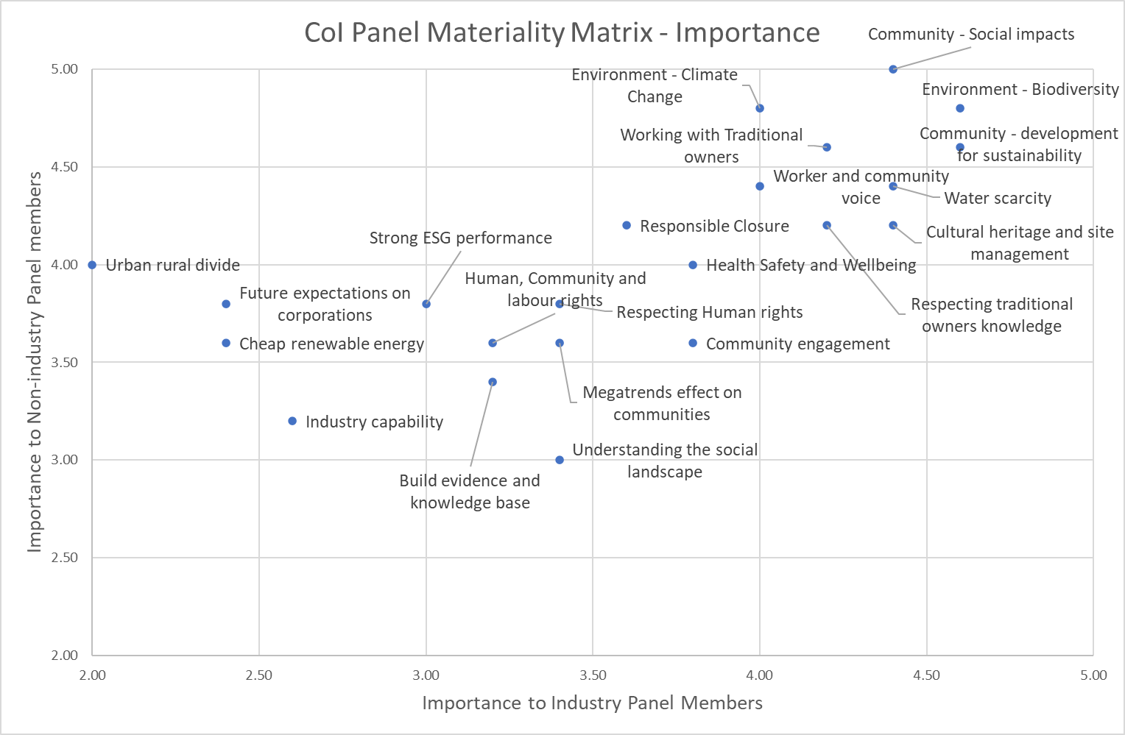

**Figure 1:** Materiality Matrix

The secretariat noted the three issues identified as most material (top right of the plot) could be identified as Community (social impacts and development for sustainability), Environment (Biodiversity with the overlay of climate change) and Water scarcity. Working with Traditional owners and Cultural heritage and site management also featured prominently.

***Action item:*** Secretariat to prepare presentation on how TSM addresses material issues.

1. **Proposed forward work program**

The secretariat noted pending approval the agenda for the next meetings could include:

* Presentations from both large and small companies on implementation journey
* Continue 5-10 mins listening to everyone in the room
* Opportunities for the Canadian CoI panel to talk with the Australian CoI
* Review of assurance and verification methodology.

Based on the materiality matrix detailed discussions on TSM criteria would start with:

* Community and social impacts
* Biodiversity
* Water

It was also noted that there was an opportunity for broader advocacy on policy issues to explore with the panel and MCA which included:

* Funds back into communities
* Speed, but also safeguards, on rapid expansion of the industry

In closing, the chair asked for any final comments.

A panel member noted in their experience, ESG standards are seen as an impost - particularly from the top. It is important that we leverage standards to improve processes and outcomes. It was discussed that a cultural shift is required for industry to avoid a ‘tick the box’ exercise. We need standards that are efficient, leverage external expertise and works by others. A panel member noted that public disclosure is a driver of performance.

A panel member noted that most companies want to do the right thing. TSM could be a vehicle for helping to demonstrate this, and the initiative will help engage people throughout the process. A panel member noted that for engagement, communities need to know they are contributing to something greater.

A panel member encouraged the MCA to take a more balanced view. There are opportunities to collaborate at a local/regional level. A panel member also noted that there are opportunities to draw on data that is readily available but not generally accessed.

***Action items:***

* Secretariat to brief absent panel members
* Secretariat to provide brief additional training sessions
* Panel members are to propose agenda items for the next meeting

1. **Summary of actions and next meeting**

The chair actions from the meeting were summarised as shown in the following table. During the meeting, a preference was expressed for the next meeting to be in mid-August.

***Action item:*** Secretariat to circulate a proposed date and location for the next meeting.

**Meeting closed**

|  |  |  |  |
| --- | --- | --- | --- |
| **Item** | **Decision / action** | **Responsibility** | **Status** |
| 1. **Welcome** | Apologies noted  Objectives agreed |  | Complete |
| 1. **Overview of TSM** | Provide a copy of the presentation  Presentation on TSM equivalency and links with other standards  Explore modern slavery guidance  Explore processes for grievances/disputes against company reports | Secretariat  Secretariat  Secretariat  Secretariat | Complete  Next meeting  Next meeting  Next meeting |
| 1. **The role of the CoI panel** | Nil |  |  |
| 1. **Terms of reference** | Provide a tracked changes copy of the Terms of Reference for approval  Committee changes to be finalised and circulated for endorsement out of session by absent panel members  Draft an overview of the role of the TSM panel and circulate for comment and approval prior to publishing  Webpages, photos, biographies and any public facing document requires approval before publication. | Secretariat  Secretariat  Secretariat  Secretariat | Attached  April  April  Noted |
| 1. **Risks, challenges and opportunities for the industry** | Provide a copy of the presentation | Secretariat | Complete |
| 1. **Prioritisation of issues** | Secretariat to prepare presentation on how TSM addresses material issues | Secretariat | Next meeting |
| 1. **Proposed forward work program** | Brief absent panel members  Provide brief additional training sessions  Propose agenda items for the next meeting | Secretariat  Secretariat  Panel members | April  Next meeting  July |
| 1. **Summary of actions and next meeting** | Next Meeting: mid August (tbc) | Secretariat | TBC |